Wireless Mouse
Enjoy wireless freedom with total optical accuracy for all your devices
Stylish in design, comfortable in use with accurate control
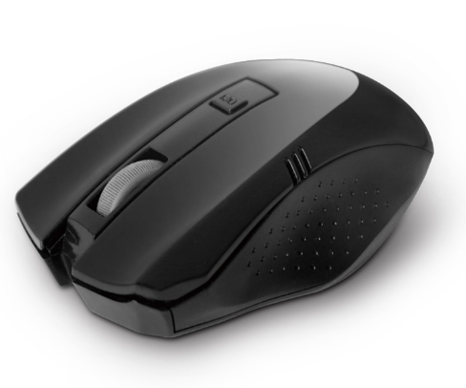

Descrption:
Freedom from wires, wherever you want

No more messy USB mouse cables. With the supplied wireless USB transceiver you can enjoy total freedom and total accuracy.

HD optical tracking

Enhanced 600dpi/1200dpi/1600dpi LED tracking gives superior on screen control for both office and gaming applications. Works on almost any surface too.
Comfortable, natural control with less strain
Carefully designed for both left and right-hand users with a more natural grip. Full, three-button technology with central scroll-wheel for easy navigation.

Control all your devices
Ideal for WindowsTM computers, notebooks, desktops and servers with any avaliable USB port.

Features:

2.4Ghz connection-free wireless mouse

Supplied with Plug n' Play wireless USB mouse transceiver

Optical tracking - ideal for all surfaces

Performance LED optics - for more accurate tracking

3 button plus scroll-wheel control for all applications

Plug n' Play - works in seconds!

Specifications
- Working Principle：2.4Ghz Radio Frequency
- CPI Button：600/1200/1600 CPI adjustable
- Buttons：Left, Right, Wheel and CPI
- Working Range：Max 10 Meters
- Wheel：1 Scrolling Wheel
- Power Consumption：3V DC 15mA
- Certificate: CE FCC ROHS
- Operating Temperature:0℃ to +45℃
- Operating Humidity:10%0 to 85 % RH
- Storage Temperature : -10℃ to +55℃
- Storage Humidity: 5% to 90 % RH

Product Code:
Part number: M360W
Barcode: 8400800026989
Size: 10.5x8x.3.8 cm
Weight: 0.116 kg

